For sale:
Plastimo Liferaft Offshore
8 Persons, Container
Typ 16250
Year 2006
Serial-Nr: 16250E0003
Service due
Price 250 euro

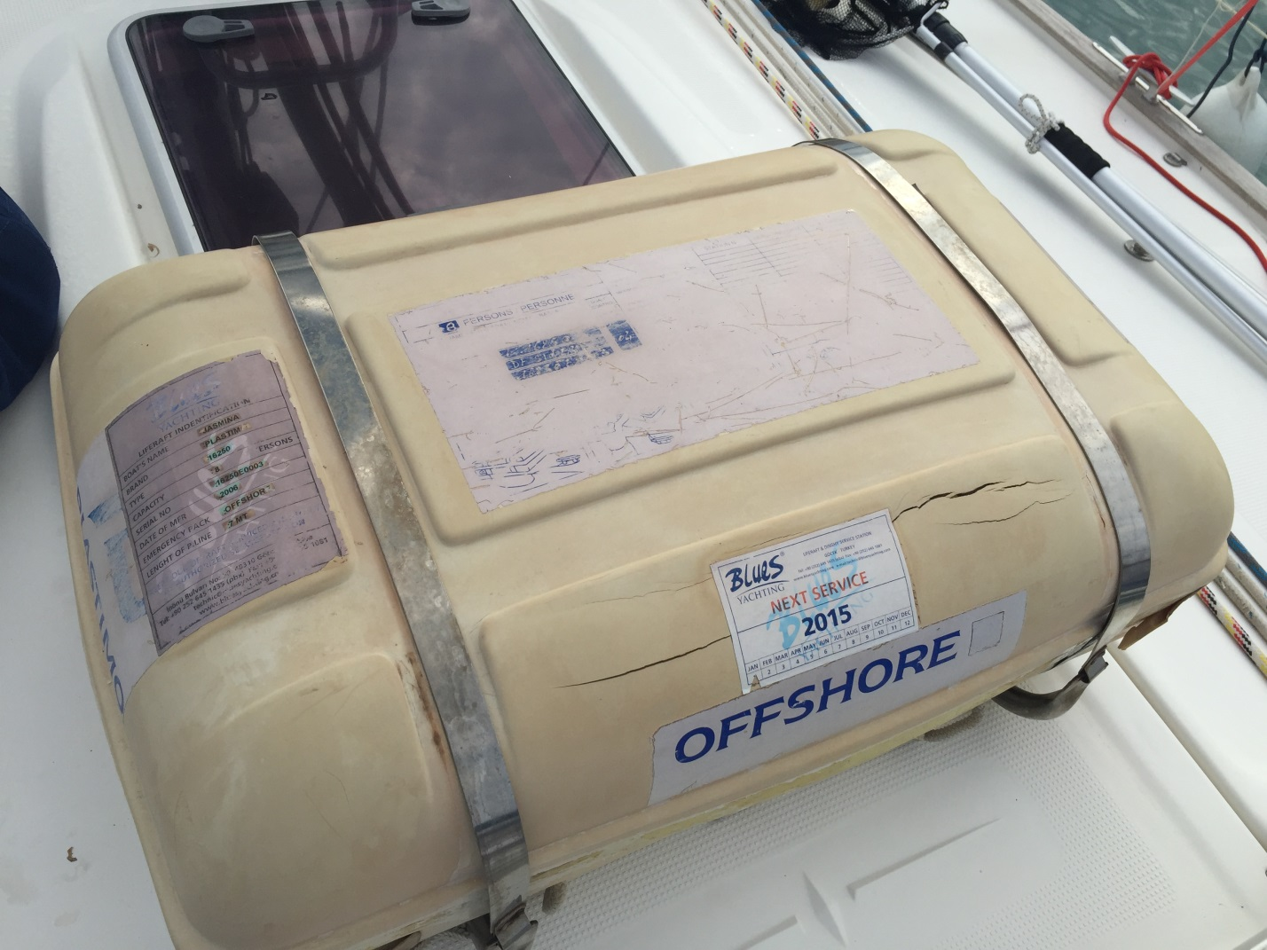

Contact
SY Easy-One
Gouvia Marina, Corfu
Ingo Mobile and Whatsapp 0049 176 4711 24 38 or Ingo.Veth@freenet.de

